Home Page

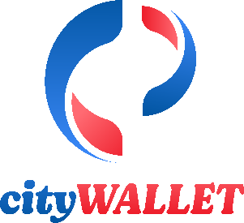

Agent Signup

Services About Contact Us Blog



Offers/Promos



Email:

Tel. No.

Toll Free

Nav bar content

FAQ  
Our Team  
News & Events  
Become An Agent  
Legal  
Downloads



Connect with us:

Wallet Transfer

QR payment

Dynamic Image

Short idea

Bullet points

Explaining features

Pay Business and Stores

Dynamic Image

Short idea

Bullet points

Explaining features

Bank and Transfers

Dynamic Image

Short idea

Bullet points

Explaining features

Remittance Pay

Dynamic Image

Short idea

Bullet points

Explaining features

Wallet Pay to   
Friends and Family:

Dynamic Image

Short idea

Bullet points

Explaining features

Services Page



Agent Signup

Services About Contact Us Blog



Email:

Tel. No.

Toll Free

Nav bar content

FAQ  
Our Team  
News & Events  
Become An Agent  
Legal  
Downloads



SMS Service

QR Payment Service

Customer Support Service

Cash Payment Service

Service

Service

Bank Transfer Service

MPOS Service

Wallet Top up

Connect with us:

About Page



Agent Signup

Services About Contact Us Blog



Div_1: What the wallet is about.  
Div_2: Our Mission  
Div_3: Our Vision  
Div_4: Our Values



Email:

Tel. No.

Toll Free

Nav bar content

FAQ  
Our Team  
News & Events  
Become an Agent  
Legal



Connect with us:

Contact Us Page



Agent Signup

Services About Contact Us Blog



Email:

Tel. No.

Toll Free

Nav bar content

Connect with us:

FAQ  
Our Team  
News & Events  
Become An Agent  
Legal  
Downloads



Blog Page

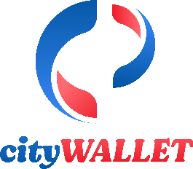

Agent Signup

Services About Contact Us Blog



Image

Read More…

Image

Read More…

Image

Read More…



Email:

Tel. No.

Toll Free

Nav bar content

Connect with us:

FAQ  
Our Team  
News & Events  
Become An Agent  
Legal  
Downloads



FAQ page



Agent Signup

Services About Contact Us Blog



Email:

Tel. No.

Toll Free

Nav bar content

Connect with us:

FAQ  
Our Team  
News & Events  
Tariffs  
Transaction Limits  
Become An Agent  
Legal



FAQ div

Hide/show

Contents: